**Bug Report**

Jaehoon Lee 11545296

## Bug Report and how did I traced each bug.

**Bug 1: Game does not pay out at correct level.**

**When player wins on 1 match, balance does not increase.**

It shows 5 points are remaining still, I traced this bug by going through game.java because if player point doesn’t increase I was sure it has error at game.java class.

## Before Fixing Bug 1

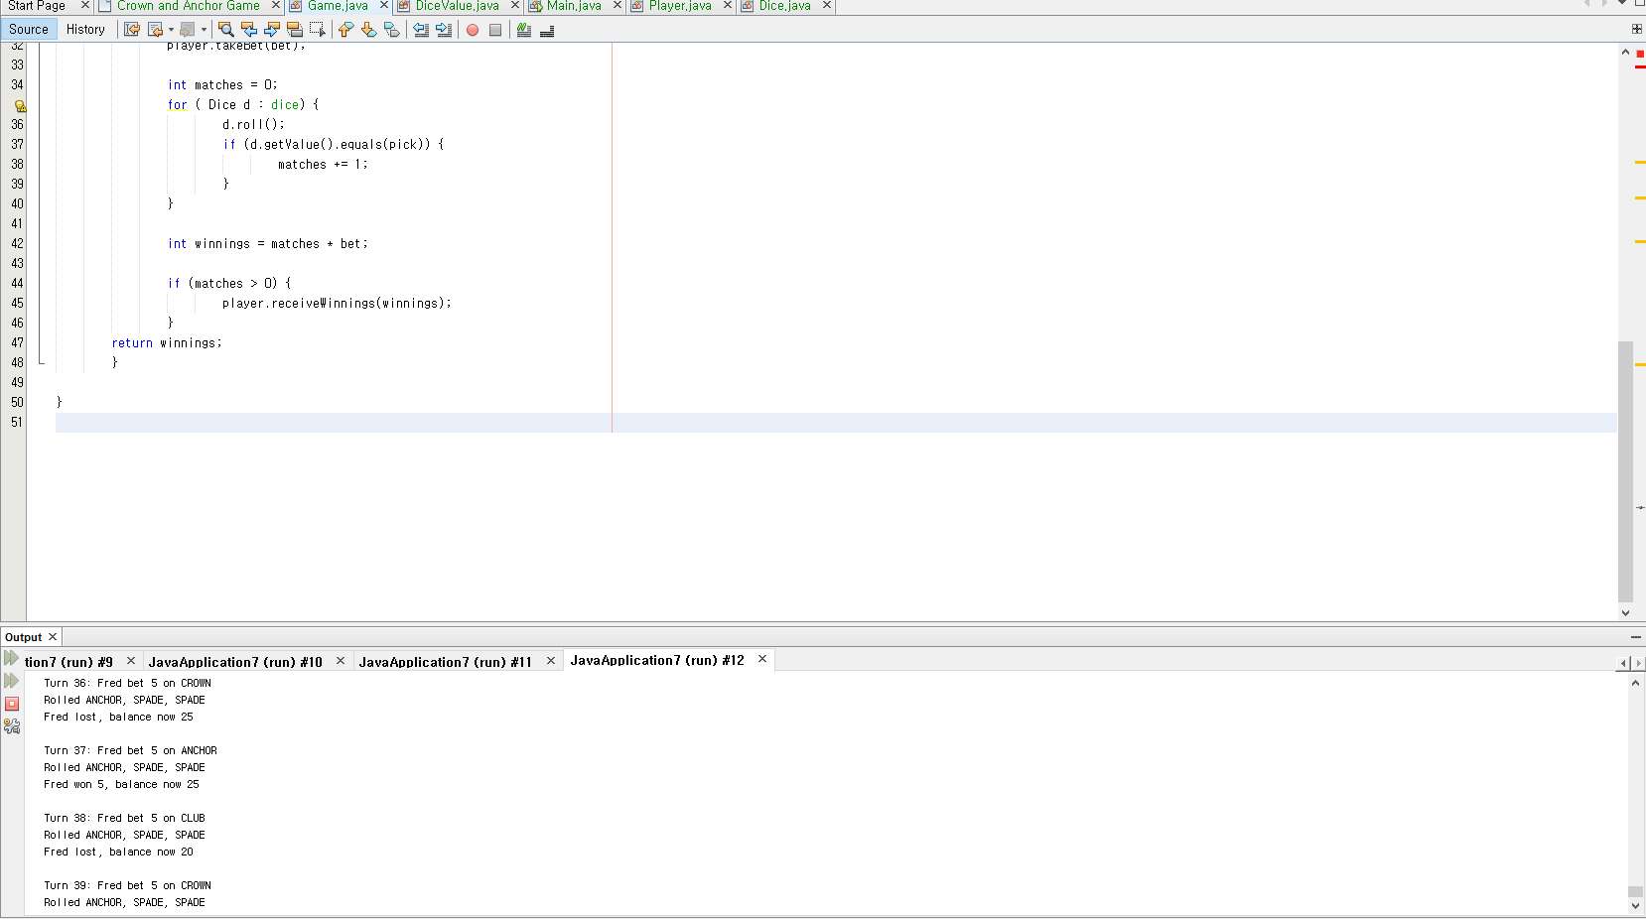

**From here as you can see the points won’t increase even the players wins the game.**

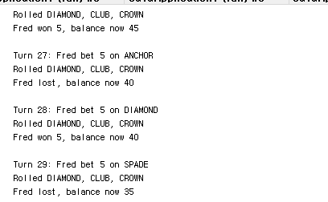

## After fixing bug 1 by adding

## + Bet in line 45 in Game.java class

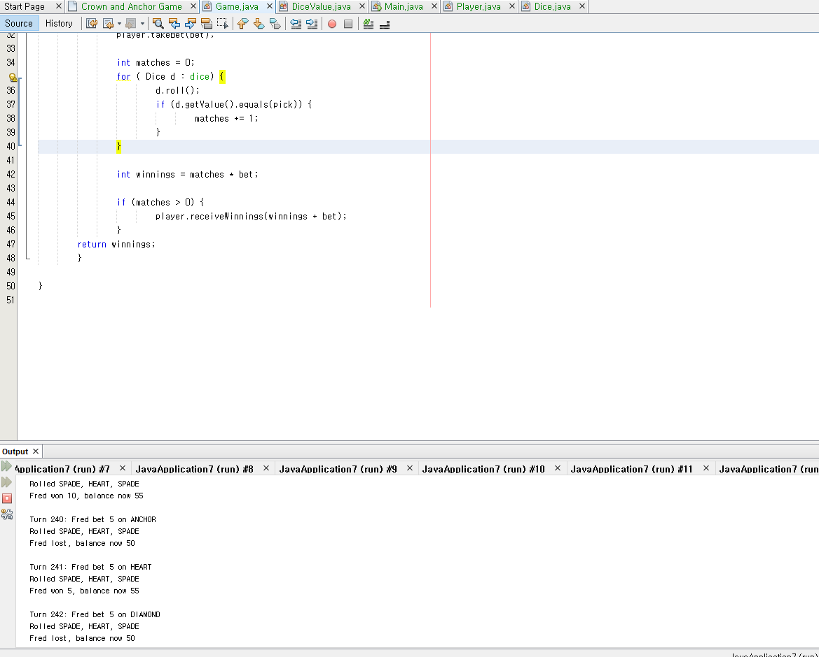

As you can see point increases after player wins.

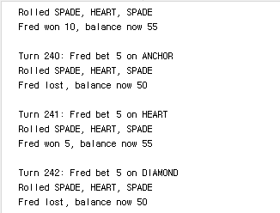

**Bug 2:** Player cannot reach betting limit:

Limit set to 0, but game ends with player still with 5 (dollars) remaining.

## Before Fixing Bug 2

**From here as you can see the player points remains at 5 point and game automatically stops. Traced this bug by going through player.java and searched for limit and I found there was an error in calculating the balance exceeds limit.**

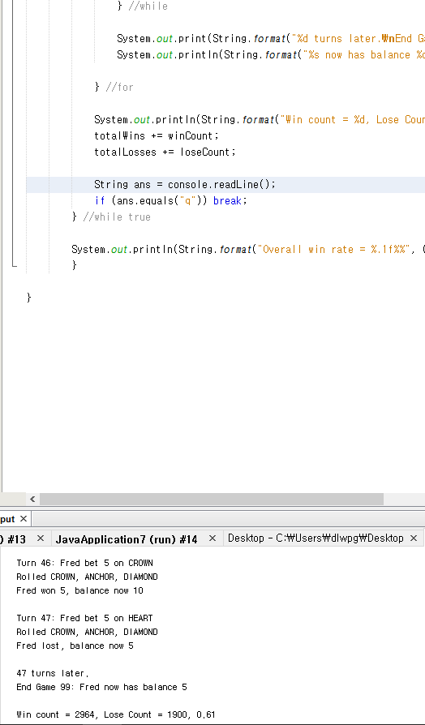

**From here as you can see the game stops even the player has 5 points remaining**

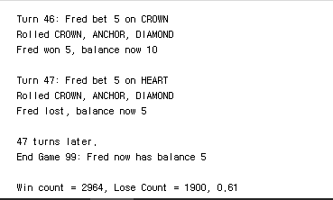

## After fixing bug 2 by adding

## + = after < in line 30 in Player.java Class

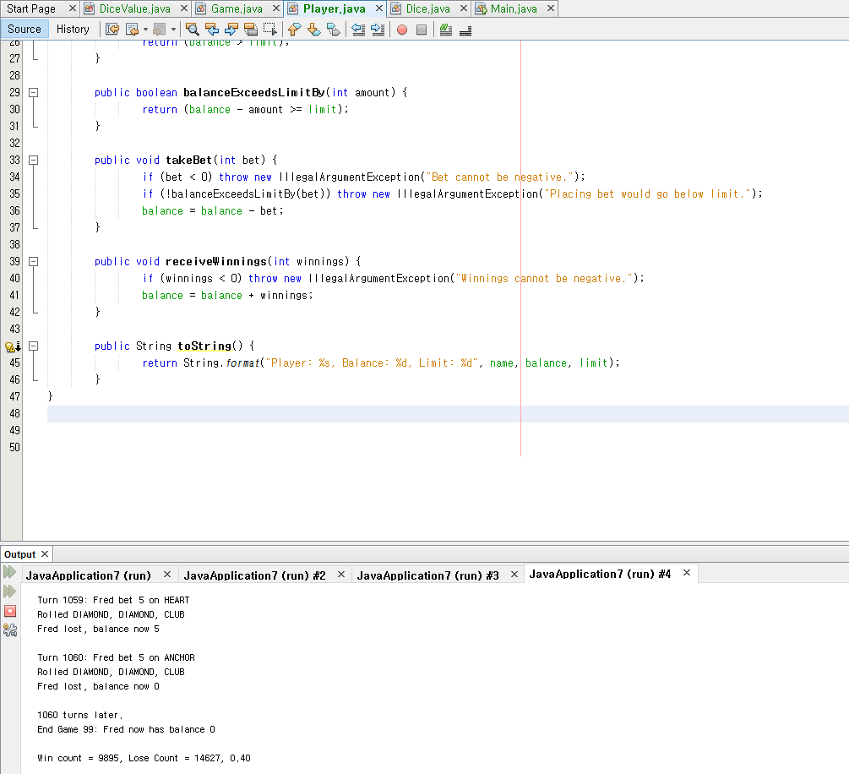

As you can see the players balance reaches 0 to stop the crown game, but still bug 3 is making an error for now.

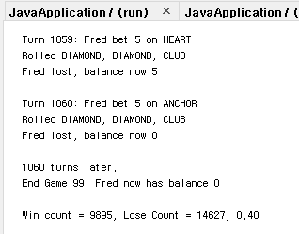

**Bug 3:** Odds in the game do not appear to be correct.

Crown and Anchor games have an approximate 8% bias to the house. So he wins: (win+lose) ratio should approximately equal 0.42. This does not appear to be the case.

## Before Fixing Bug 3

**From here as you can see** **Crown and Anchor games have an approximate 8% bias to the house. So he wins: (win+lose) ratio should approximately equal 0.42. This does not appear to be the case. It is saying 0.40**

**Traced this bug by going through the game setting and dice settings and dice value java class and found an error in setting randomized values.**



**From here as you can see the game won’t show proper: (win+lose) ratio should approximately equal 0.42. This does not appear to be the case.**



## After fixing bug 3 by adding

## + int random = RANDOM.nextInt(values().length);

## return values()[random]; in line 26~28 in DiceValue.java Class and return value; line 13~15 in Dice.java Class.

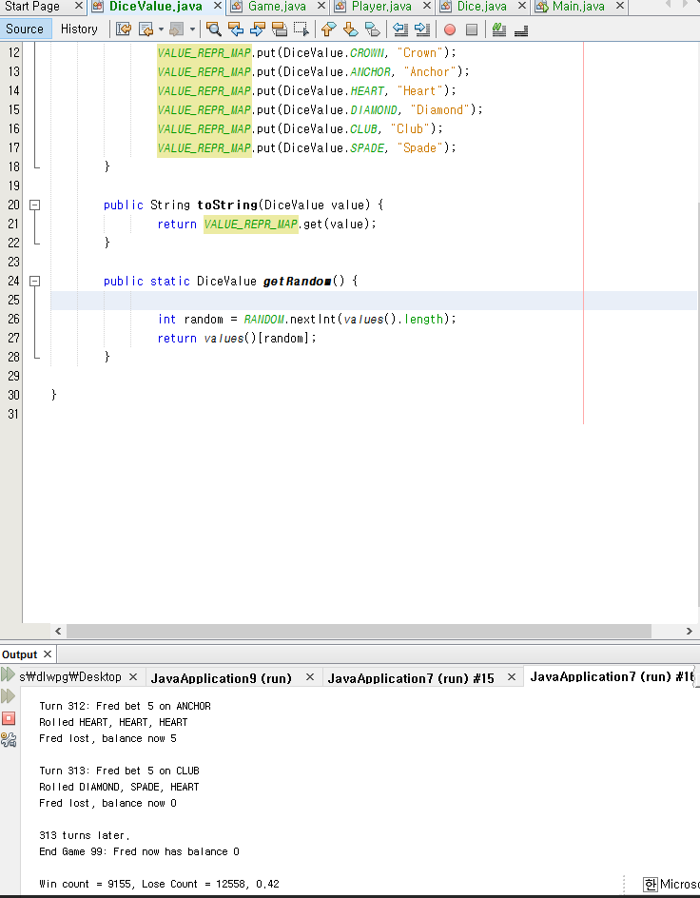

**From here as you can see I added return value; in dice.java class**

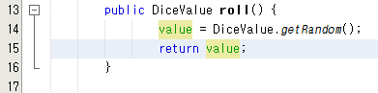

**And the result is saying 0.42**

